Chapter 15, Solution 11.

- Since 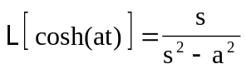
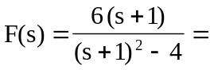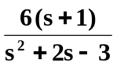

- Since 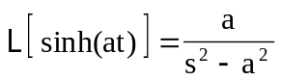
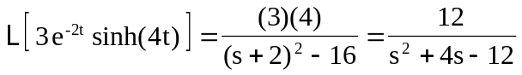

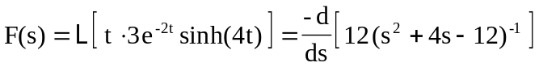
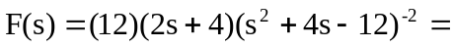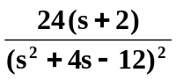

- 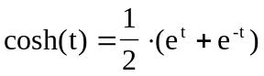
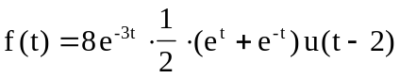
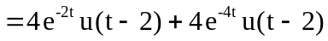

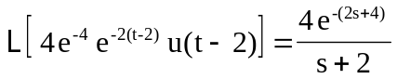

Similarly, 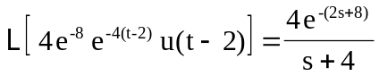

Therefore,
